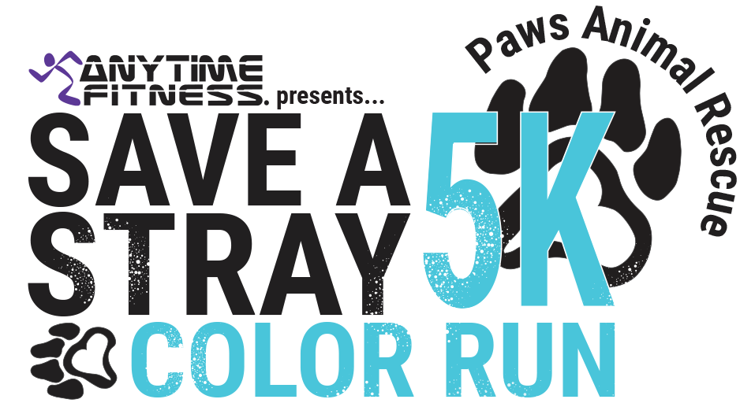

Extra Donation (Optional): $ (Money to go to **Paws Animal Rescue** a 501(c)3 non-profit organization. Thank you!)

**TOTAL:**  Check: Cash:

Registration Fee: $25

____ $2 extra Opt out shirt (will indicate to throwers that you choose not to be hit with color)

T-Shirt Size: S M L XL 2XL

Email Address:

Phone Number:

City: ___________________________ State: _____________ Zip: ________

Staff use only:

___ Liability Waiver signed

___ Payment received

Address:

Last Name:

First Name: